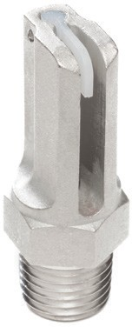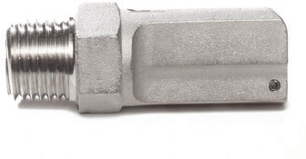
120-3
1.7-2.2
3 feet
4ft / 30° down
2’ / 15° down
1/4”
3 feet
Boom Buster Agricultural Spray Nozzles feature large droplet size which reduces spray drift and promotes spray penetration. Particularly useful when spraying herbicides, fungicides, insecticides, fertilizer, nitrogen and foliar feed fertilizers. Ideal for orchards, vineyards, row crops, forestry, pastures, turf, golf-courses, nurseries, ponds, poultry houses and more.
MOUNTING (NPT) SPRAY PATTERN
MOUNTING HEIGHT/ANGLE
SPRAY DISTANCE
OUTPUT RANGE
(gallons per minute)
MODEL #

120-5

1.7-2.2

5 feet 4ft / 15° down
2’ / 7° down

16 feet
1/4”

125

1.7-2
5 feet
16 feet 4ft / level 1/4”

140

180-6

180-10
2-2.7

3.6-4.8

3.6-4.8
17 feet 4ft / level

6 feet 4ft / 30° down
2’ / 15° down

10 feet 4ft / 15° down
2’ / 7° down

19 feet
1/4”

3/8”

17 feet
6 feet

3/8”

10 feet

187

3.6-4.8
19 feet 4ft / level 3/8”

260-5

260-11

265

370
6.8-8.8

6.8-8.8

6.8-8.8

14.4-18.8
5 feet 4ft / 30° down
2’ / 15° down

11 feet 4ft / 15° down
2’ / 7° down

20 feet 4ft / level

10 feet 4ft / 15° down
2’ / 7° down
1/2”

1/2”

5 feet
11 feet

1/2”

20 feet

3/4”

10 feet

375

437

500

504
14.4-18.8

18.5-24.2

29-37

29-37
22 feet 4ft / level 3/4”

30 feet 4ft / 15° up 3/4”

30 feet

22 feet

20 feet 4ft / level 1”

20 feet

40 feet 4ft / 30° up 1”

40 feet

MOUNTING (NPT) SPRAY PATTERN
MOUNTING HEIGHT/ANGLE
SPRAY DISTANCE
OUTPUT RANGE
(gallons per minute)
MODEL #
*Nozzle mounting height and angles listed are approximate.

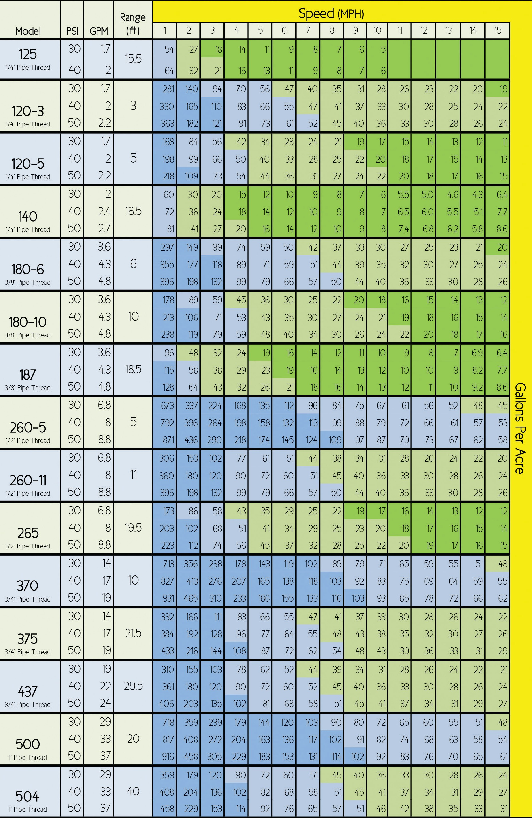
Application Chart - Agricultural Applications

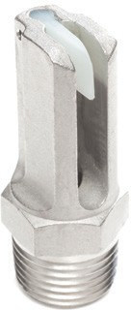
Nozzle Selection Guide - Roadside/Right-of-Way Applications
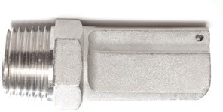
Boom Buster R-model spray nozzles are ideal for spraying fence lines and rights-of-way. Highly effective for de-icing roads and bridges, dust suppression, weed control and fighting grass and brush fires. May be used with tank-mix systems and computer-controlled direct injection systems. Large droplet size allows the user to maintain pattern at higher speeds.
MOUNTING (NPT) SPRAY PATTERN
MOUNTING HEIGHT/ANGLE
SPRAY DISTANCE
OUTPUT RANGE
(gallons per minute)
MODEL #

120-3R
1.7-2.2
3 feet
4ft / 30° down
2’ / 15° down
1/4”
3 feet

120-5R

1.7-2.2

5 feet 4ft / 15° down
2’ / 7° down

16 feet
1/4”

125R

17 feet

1.7-2.0
5 feet
- feet 4ft / level 1/4”

140R

2.0-2.7

- feet 4ft / level
1/4”

180-6R
3.6-4.8
6 feet
4ft / 30° down
2’ / 15° down
3/8”
6 feet

180-10R

3.6-4.8

10 feet 4ft / 15° down
2’ / 7° down

19 feet
3/8”

187R

3.6-4.8

10 feet
19 feet 4ft / level 3/8”

260-5R

260-11R

265R

370R
6.8-8.8

6.8-8.8

6.8-8.8

14.4-18.8
5 feet 4ft / 30° down
2’ / 15° down

11 feet 4ft / 15° down
2’ / 7° down

20 feet 4ft / level

10 feet 4ft / 15° down
2’ / 7° down
1/2”

1/2”

5 feet
11 feet

1/2”

20 feet

3/4”

10 feet

375R

437R

500R

504R

14.4-18.8

18.5-24.2

29-37

29-37
22 feet 4ft / level 3/4”

30 feet 4ft / 15° up 3/4”

30 feet

22 feet

20 feet 4ft / level 1”

20 feet

40 feet 4ft / 30° up 1”

40 feet

MOUNTING (NPT) SPRAY PATTERN
MOUNTING HEIGHT/ANGLE
SPRAY DISTANCE
OUTPUT RANGE
(gallons per minute)
MODEL #

*Nozzle mounting height and angles listed
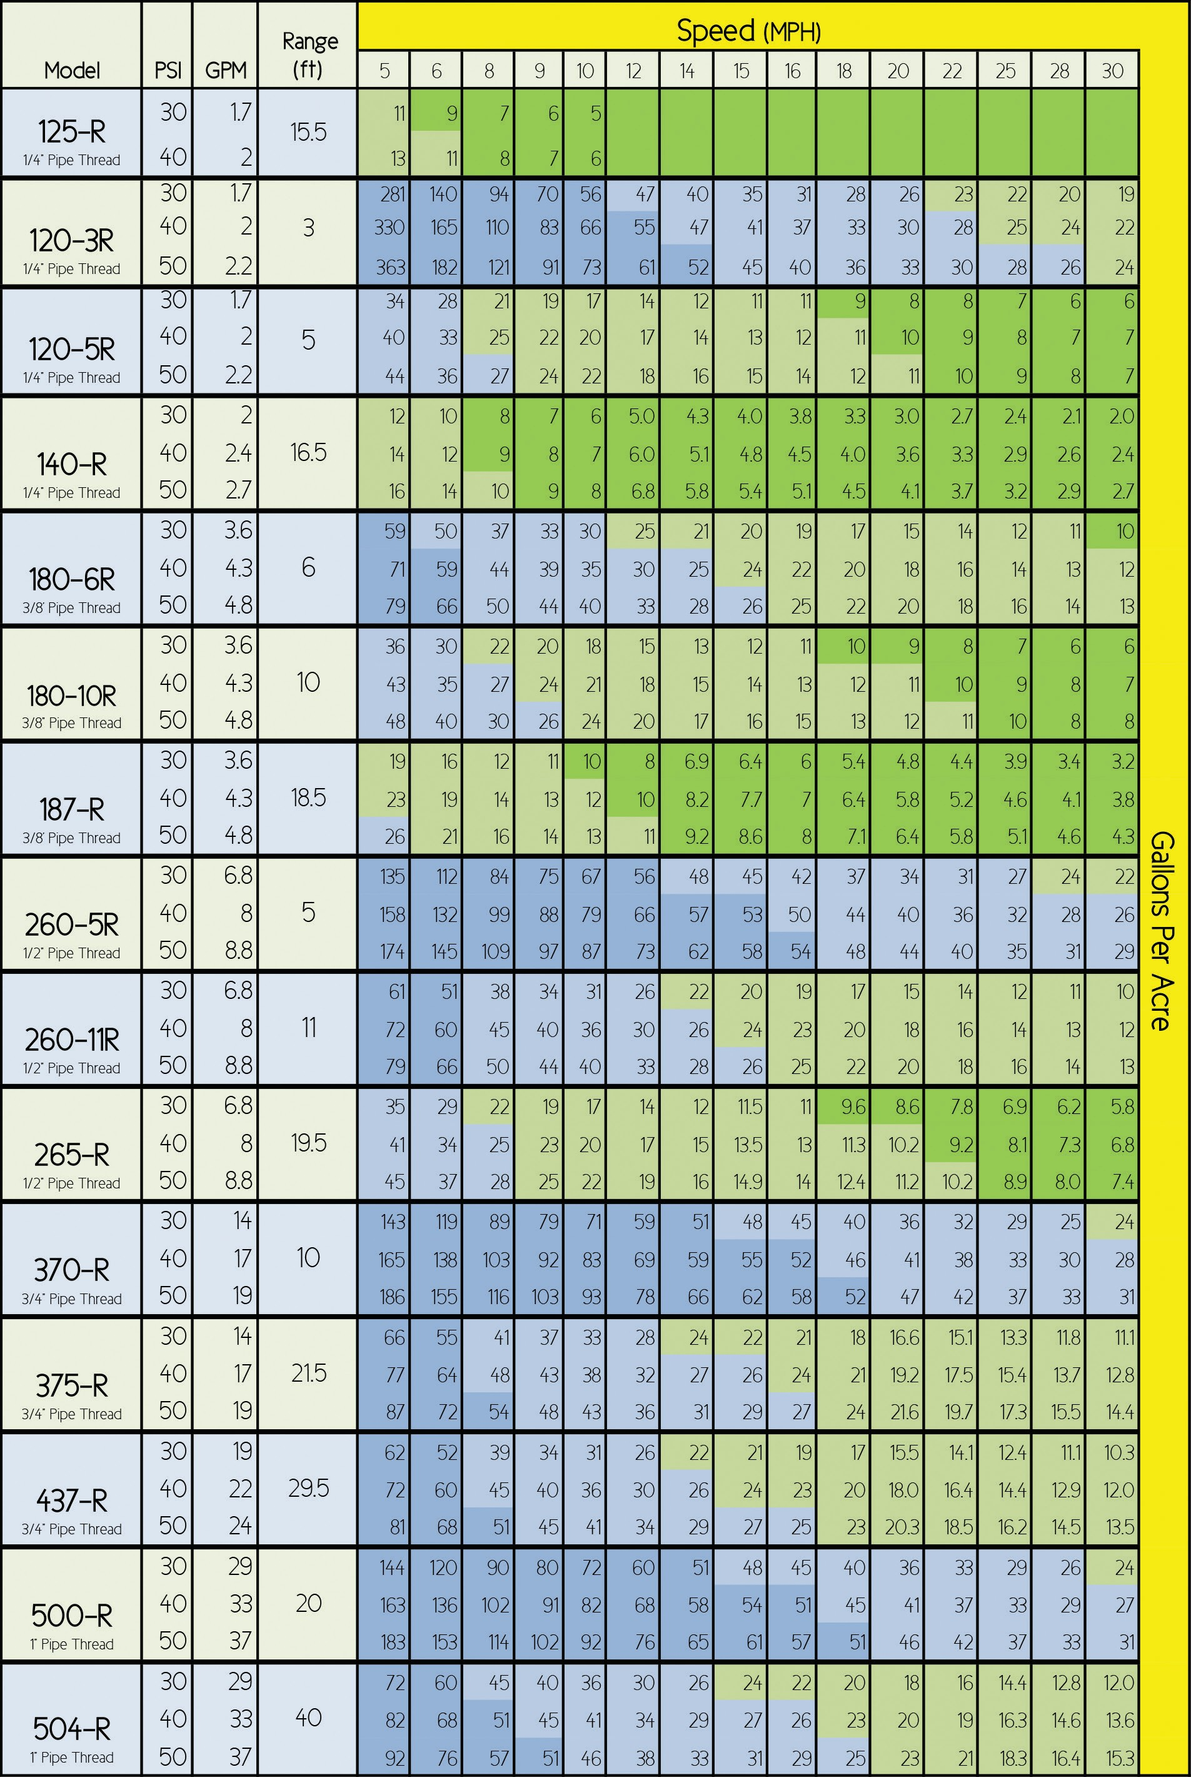
Application Chart - Roadside/Right of Way

